Direct Memory Access
Although interrupt driven I/O is much more efficient than program controlled I/O, all data is still transferred through the CPU. This will be inefficient if large quantities of data are being transferred between the peripheral and memory. The transfer will be slower than necessary, and the CPU will be unable to perform any other actions while it is taking place.
Many systems therefore use an additional strategy, known as direct memory access (DMA). DMA uses an additional piece of hardware - a DMA controller. The DMA controller can take over the system bus and transfer data between an I/O module and main memory without the intervention of the CPU. Whenever the CPU wants to transfer data, it tells the DMA controller the direction of the transfer, the I/O module involved, the location of the data in memory, and the size of the block of data to be transferred. It can then continue with other instructions and the DMA controller will interrupt it when the transfer is complete.
The CPU and the DMA controller cannot use the system bus at the same time, so some way must be found to share the bus between them. One of two methods is normally used.
Burst mode
The DMA controller transfers blocks of data by halting the CPU and controlling the system bus for the duration of the transfer. The transfer will be as quick as the weakest link in the I/O module/bus/memory chain, as data does not pass through the CPU, but the CPU must still be halted while the transfer takes place.
Cycle stealing
The DMA controller transfers data one word at a time, by using the bus during a part of an instruction cycle when the CPU is not using it, or by pausing the CPU for a single clock cycle on each instruction. This may slow the CPU down slightly overall, but will still be very efficient.

I/O Organization in Microprocessors
A computer system is comprised of three main functional blocks:
  - A central processing unit
  - Main memory
  - Input/output (I/O)
The I/O section of the computer can be broken down into two parts.
  - The I/O devices themselves (peripherals)
  - The I/O modules

I/O Modules
It is not possible to simply connect I/O devices directly to the system bus for several reasons.
  - There are many different types of device, each with a different method of operation, e.g. monitors, disk drives, keyboards. It is impracticable for a CPU to be aware of the operation of every type of device, particularly as new devices may be designed after the CPU has been produced.
  - The data transfer rate of most peripherals is much slower than that of the CPU. The CPU cannot communicate directly with such devices without slowing the whole system down.
  - Peripherals will often use different data word sizes and formats than the CPU.
For this reason a computer system must use I/O modules, components which interface between the CPU and the peripherals. An I/O module has several functions.
  - Controlling the peripheral and synchronizing its operation with that of the CPU
  - Communicating with the CPU through the system bus
  - Communicating with the peripheral through an I/O interface
  - Buffering data
  - Error detection
An I/O module consists of several parts.
  - A connection to the system bus
  - Some control logic
  - A data buffer
  - An interface to the peripheral(s)
The following diagram shows a system configuration for a CPU with two I/O devices connected to it:
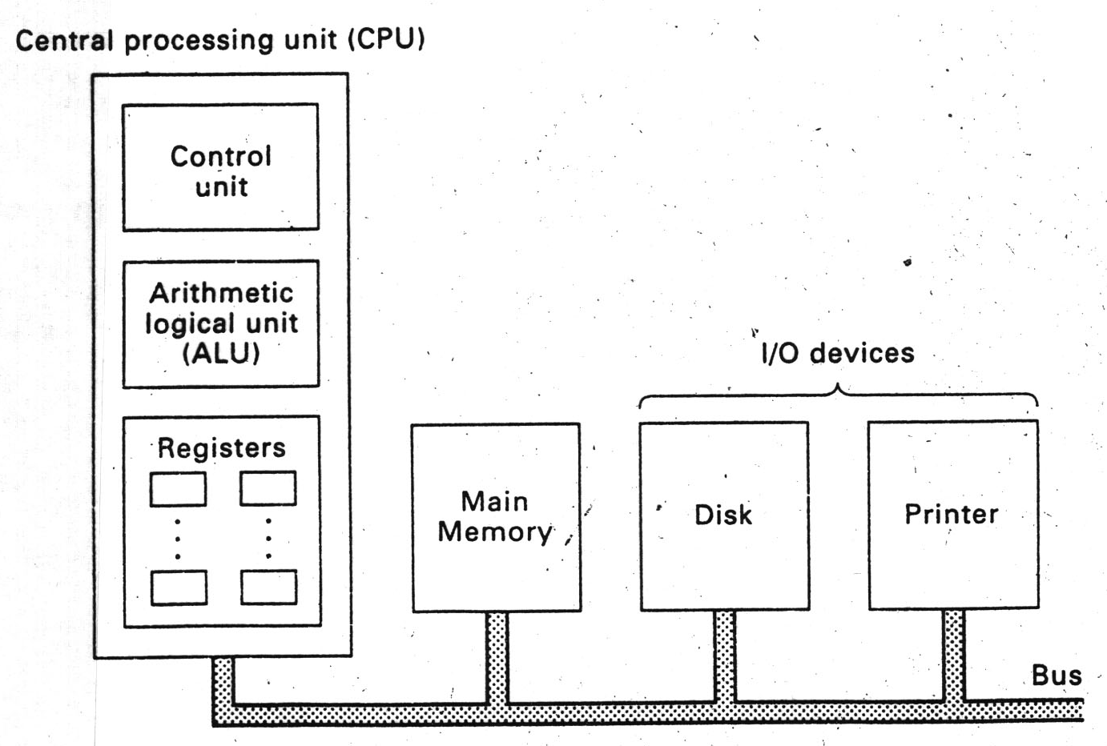

I/O Implementation Alternative

Memory Mapped and Isolated I/O
Whether a system uses programmed or interrupt driven I/O, it must still periodically send instructions to the I/O modules. Two methods are used for to implement this: memory-mapped I/O and isolated I/O.
With memory-mapped I/O, the I/O modules appear to the CPU as though they occupy locations in main memory. To send instructions or transfer data to an I/O module, the CPU reads or writes data to these memory locations. This will reduce the available address space for main memory, but as most modern systems use a wide address bus this is not normally a problem.
With isolated I/O, the I/O modules appear to occupy their own address space, and special instructions are used to communicate with them. This gives more address space for both memory and I/O modules, but will increase the total number of different instructions. It may also reduce the flexibility with which the CPU may address the I/O modules if less addressing modes are available for the special I/O instructions.

I/O Implementation Alternatives

Programmed I/O
The simplest strategy for handling communication between the CPU and an I/O module is programmed I/O. Using this strategy, the CPU is responsible for all communication with I/O modules, by executing instructions which control the attached devices, or transfer data.
For example, if the CPU wanted to send data to a device using programmed I/O, it would first issue an instruction to the appropriate I/O module to tell it to expect data. The CPU must then wait until the module responds before sending the data. If the module is slower than the CPU, then the CPU may also have to wait until the transfer is complete. This can be very inefficient.
Another problem exists if the CPU must read data from a device such as a keyboard. Every so often the CPU must issue an instruction to the appropriate I/O module to see if any keys have been pressed. This is also extremely inefficient. Consequently this strategy is only used in very small microprocessor controlled devices.

I/O Implementation Alternative

Interrupt Driven I/O
A more common strategy is to use interrupt driven I/O. This strategy allows the CPU to carry on with its other operations until the module is ready to transfer data. When the CPU wants to communicate with a device, it issues an instruction to the appropriate I/O module, and then continues with other operations. When the device is ready, it will interrupt the CPU. The CPU can then carry out the data transfer as before.
This also removes the need for the CPU to continually poll input devices to see if it must read any data. When an input device has data, then the appropriate I/O module can interrupt the CPU to request a data transfer.
An I/O module interrupts the CPU simply by activating a control line in the control bus. The sequence of events is as follows.
1. The I/O module interrupts the CPU.
2. The CPU finishes executing the current instruction.
3. The CPU acknowledges the interrupt.
4. The CPU saves its current state.
5. The CPU jumps to a sequence of instructions, which will handle the interrupt.
The situation is somewhat complicated by the fact that most computer systems will have several peripherals connected to them. This means the computer must be able to detect which device an interrupt comes from, and to decide which interrupt to handle if several occur simultaneously. This decision is usually based on interrupt priority. Some devices will require response from the CPU more quickly than others; for example, an interrupt from a disk drive must be handled more quickly than an interrupt from a keyboard.
Many systems use multiple interrupt lines. This allows a quick way to assign priorities to different devices, as the interrupt lines can have different priorities. However, it is likely that there will be more devices than interrupt lines, so some other method must be used to determine which device an interrupt comes from.
Most systems use a system of vectored interrupts. When the CPU acknowledges an interrupt, the relevant device places a word of data (a vector) on the data bus. The vector identifies the device, which requires attention, and is used by the CPU to look up the address of the appropriate interrupt handing routine.

