Memory Type: by storing process
There are two major classifications of memory devices, depending on the manner of their storage of memory. Programs can only be read in Read-Only Memory (ROM), while programs can either be written or read on Random Access Memory (RAM).
Below is a diagram of memory hierarchy, to help you visualize memory arrangement in a computer.
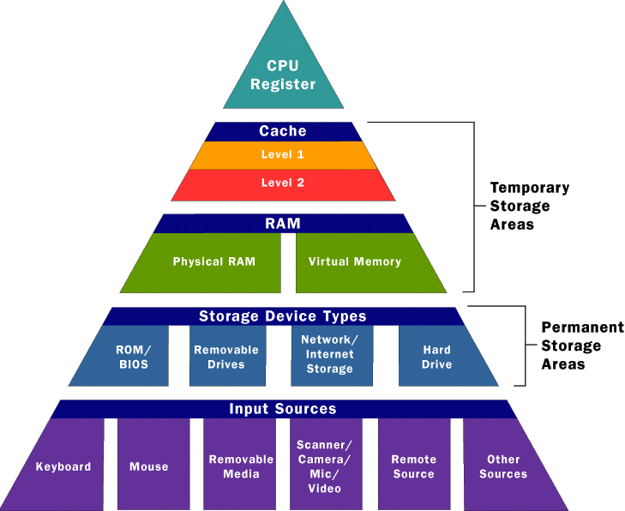

Read-Only Memory (ROM)
One major type of memory that is used in PCs is called read-only memory, or ROM for short. ROM is a type of memory that normally can only be read, as opposed to RAM, which can be both read and written.
ROM is very important for the following reasons:
1. Permanence: The values stored in ROM are always there, whether the power is on or not. This is also called non-volatile memory
2. Security: Since ROM cannot easily be modified it provides a measure of security against accidental (or malicious) changes to its contents. It is also for this reason why the BIOS of the computers are stored in ROM.
There are also different types of ROM, depending on their relative modifiability:
· Regular ROM: the program it contains is hard-wired, that is, it is soldered directly on the chip
• Programmable ROM (PROM): this type of ROM can be programmed only once, usually by the manufacturers
• Erasable Programmable ROM (EPROM): An EPROM is a ROM that can be erased and reprogrammed. Ultraviolet light erases the program installed inside through the glass window on the top of the chip.
• Electrically Erasable Programmable ROM (EEPROM): this quite similar to EPROM, except that the erasing and programming are both done electrically.
Random Access Memory (RAM)
RAM, or random access memory, is used for holding programs and data being executed. It differs with ROM because data or program can also be written to it, not only read from it.
There are also different types of RAM, depending on the frequency of memory refresh:
1. Static RAM (SRAM)
Static RAM is a type of RAM that holds its data without external refresh, for as long as power is supplied to the circuit. This is contrasted to dynamic RAM (DRAM), which must be refreshed many times per second in order to hold its data contents. SRAMs are used for specific applications within the PC, where their strengths outweigh their weaknesses compared to DRAM:
- Simplicity: SRAMs don't require external refresh circuitry or other work in order for them to keep their data intact.
- Speed: SRAM is faster than DRAM.
In contrast, SRAMs have the following weaknesses, compared to DRAMs:
- Cost: SRAM is, byte for byte, several times more expensive than DRAM.
- Size: SRAMs take up much more space than DRAMs
These advantages and disadvantages taken together show that performance-wise, SRAM is superior to DRAM. Unfortunately, 32 MB of SRAM would be prohibitively large and costly, which is why DRAM is used for system memory. SRAMs are used instead for level 1 and level 2 cache memory, for which it is perfectly suited; cache memory needs to be very fast, and not very large.
2. Dynamic RAM (DRAM)
This type of RAM is called dynamic because the memory has to be refreshed several times in a second. A special circuit called the refresh circuit reads the content of the DRAM several times a second. This reading action refreshes the memory. Reading every "row" in the memory chip one row at a time does refreshing; the process of reading the contents of each capacitor in the memory circuit re-establishes the charge.
Read Only Memory
There are five basic ROM types:
- ROM
- PROM
- EPROM
- EEPROM
- Flash Memory
All of them share the same characteristics: they are non-volatile and requires a special process to reprogram it.

PROM
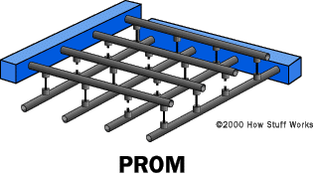
PROM have a grid of columns and rows just as ordinary ROMs do. The difference is that every intersection of a column and row in a PROM chip has a fuse connecting them. A charge sent through a column will pass through the fuse in a cell to a grounded row indicating a value of "1." Since all the cells have a fuse, the initial, or blank, state of a PROM chip is all "1"s. To change the value of a cell to "0," you use a special tool called a programmer to send a specific amount of current to the cell. The higher voltage breaks the connection between the column and row by burning out the fuse. This process is known as burning the PROM.
PROMs can only be programmed once. They are more fragile than ROMs. A jolt of static electricity can easily cause fuses in the PROM to burn out, changing essential bits from "1" to "0". But blank PROMs are inexpensive and are great for prototyping the data for a ROM before committing to the costly ROM fabrication process.
Erasable Programmable Read-Only Memory
EPROM addresses the issue of reprogramming a ROM; these chips can be rewritten many times. Erasing an EPROM requires a special tool that emits a certain frequency of ultraviolet (UV) light. EPROMs are configured using an EPROM programmer that provides voltage at specified levels, depending on the type of EPROM used.
To rewrite an EPROM, you must erase it first. To erase it, you must supply a level of energy strong enough to break through the negative electrons blocking. In a standard EPROM, this is best accomplished with UV light at a frequency of 253.7. Because this particular frequency will not penetrate most plastics or glasses, each EPROM chip has a quartz window on top of the chip. The EPROM must be very close to the eraser's light source, within an inch or two, to work properly. An EPROM eraser is not selective; it will erase the entire EPROM. The EPROM must be removed from the device it is in and placed under the UV light of the EPROM eraser for several minutes.
EEPROMs and Flash Memory
Though EPROMs are a big step up from PROMs in terms of reusability, they still require dedicated equipment and a labor-intensive process to remove and reinstall them each time a change is necessary. Also, changes cannot be made incrementally to an EPROM. The whole chip must be erased. Electrically Erasable Programmable Read-Only Memory (EEPROM) chips remove the biggest drawbacks of EPROMs.
The EEPROM chips can be reprogrammed electrically. The chip doesn't have to be removed from its place, and programming can be selective. The only drawback is the speed of programming. For applications that require fast writing, EEPROM cannot perform well.
Manufacturers responded to this limitation with flash memory, a type of EEPROM that uses in-circuit wiring to erase by applying an electrical field to the entire chip or predetermined sections of it called blocks. Flash memory works much faster than traditional EEPROMs because it writes data in chunks, usually 512 bytes in size, instead of a byte at a time.
Memory Type: by Module Form Factors
The form factor of any memory module describes its size and pin configuration.
In a way, it is classifies memory by its physical characteristic, although not completely.
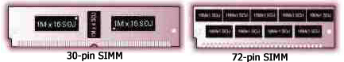

SIMMS
SIMM stands for Single In-Line Memory Module. With SIMMs, memory chips are soldered onto a modular printed circuit board (PCB), which inserts into a socket on the system board.
The first SIMMs transferred 8 bits of data at a time. Later, as CPUs began to read data in 32-bit chunks, a wider SIMM was developed, which could supply 32 bits of data at a time. The easiest way to differentiate between these two different kinds of SIMMs was by the number of pins, or connectors. The earlier modules had 30 pins and the later modules had 72 pins.
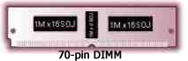

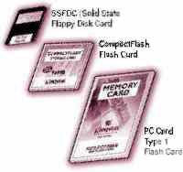
DIMMS
Dual In-line Memory Modules, or DIMMs, closely resemble SIMMs. Like SIMMs, most DIMMs install vertically into expansion sockets. The principal difference between the two is that on a SIMM, pins on opposite sides of the board are "tied together" to form one electrical contact; on a DIMM, opposing pins remain electrically isolated to form two separate contacts.
168-pin DIMMs transfer 64 bits of data at a time and are typically used in computer configurations that support a 64-bit or wider memory bus. Some of the physical differences between 168-pin DIMMs and 72-pin SIMMs include: the length of module, the number of notches on the module, and the way the module installs in the socket. Another difference is that many 72-pin SIMMs install at a slight angle, whereas 168-pin DIMMs install straight into the memory socket and remain completely vertical in relation to the system motherboard.

SO DIMMS
A type of memory commonly used in notebook computers is called SO DIMM or Small Outline DIMM. The principal difference between a SO DIMM and a DIMM is that the SO DIMM, because it is intended for use in notebook computers, is significantly smaller than the standard DIMM. The 72-pin SO DIMM is 32 bits wide and the 144-pin SO DIMM is 64 bits wide.
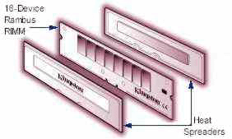
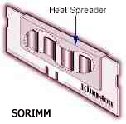
RIMMS AND SO-RIMMS
RIMM is the trademarked name for a Direct Rambus memory module. RIMMs look similar to DIMMs, but have a different pin count. RIMMs transfer data in 16-bit chunks. A 184-pin Direct Rambus RIMM shown with heat spreaders pulled away.

An SO-RIMM looks similar to an SO DIMM, but it uses Rambus technology.

FLASH MEMORY
Flash memory is a solid-state, non-volatile, rewritable memory that functions like RAM and a hard disk drive combined. Flash memory stores bits of electronic data in memory cells, just like DRAM, but it also works like a hard-disk drive in that when the power is turned off, the data remains in memory. Because of its high speed, durability, and low voltage requirements, flash memory is ideal for use in many applications - such as digital cameras, cell phones, printers, handheld computers, pagers, and audio recorders.

PC CARD AND CREDIT CARD MEMORY
Memory devices used in notebook computers are packaged in modules that looked like credit cards. Because of its compact form factor, credit card memory was ideal for notebook applications where space is limited.

Read/Write Memory
Accessing of memory by the CPU doesn't happen automatically. It takes some time before the CPU can access the data or program it needs from the memory. Since all systems around the microprocessor run with the system clock, the read/write operation can also be understood better from this vantage point.

Typical Read Operation
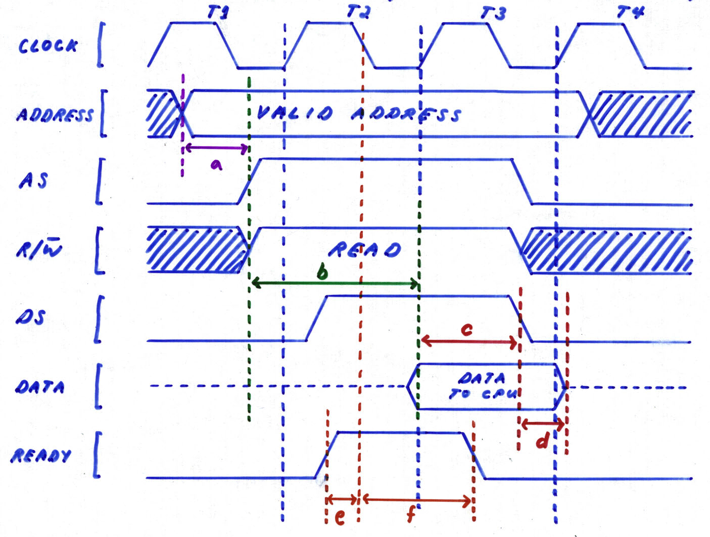
legend: a - address set-up time
b - memory access time
c - data set-up time
d - data hold time
e - READY set-up time
f - READY hold time

