Typical Write Operation
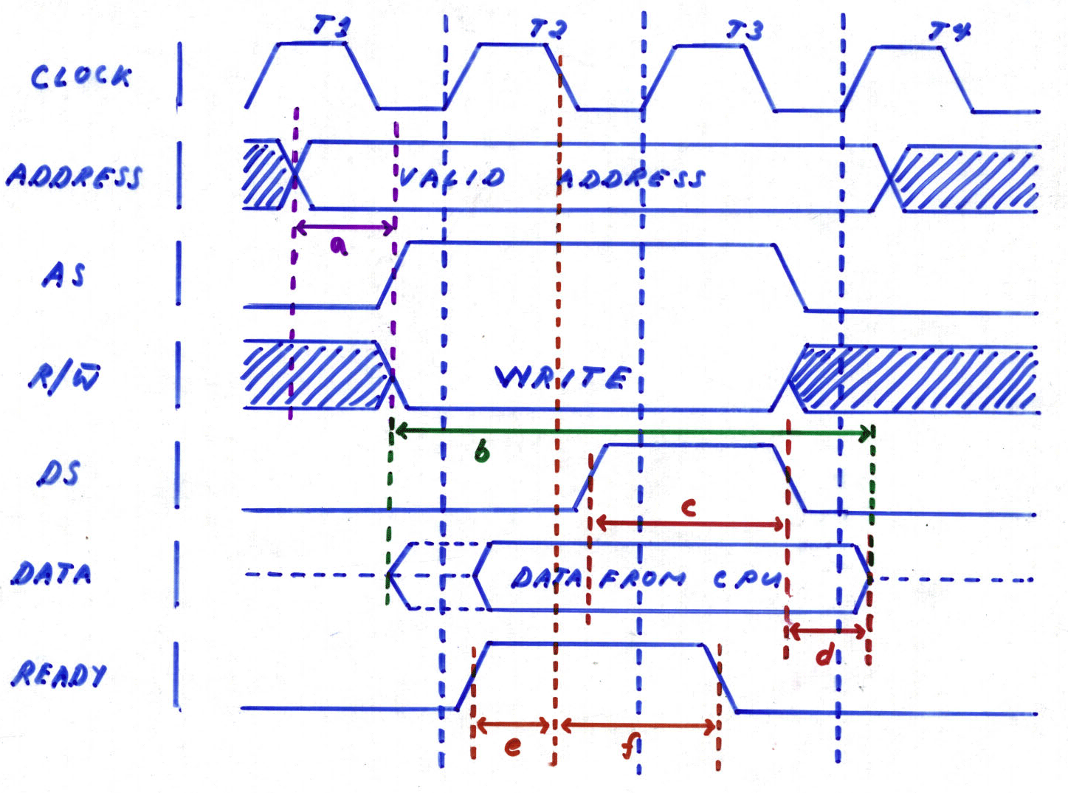
legend: a - address set-up time
b - data width >= write time of memory
c - minimum time for DS
d - data hold time
e - READY set-up time
f - READY hold time
As can be seen from the graphs, data can only be read or written when the address is already valid. The address strobe, the Read/Write, and the data pin must be high in order for the read/write operation to get through. Try to study again the read/write sequence.

Memory Management: Error Checking
Data are stored in memory in 1's and 0's. This is due to the binary nature of electronics. However, as in any system, errors can often be found. These errors can be due to hardware, probably a loosened connection or disconnected joints/soldering. As such, it generates what we call repeatable or hard error. The second kind of error is called a transient or soft error. This occurs when a bit reads back the wrong value once, but subsequently functions correctly. These problems are, understandably, much more difficult to diagnose! They are also, unfortunately, more common.
There are ways to find and correct these errors. Some can only detect it; the other can correct it as well.
PARITY
When parity is in use on a computer system, one parity bit is stored in DRAM along with every 8 bits (1 byte) of data. Parity simply counts the number of 1's and 0's in a given bit, since data are stored in binary. In each parity protocol, a bit is generated to indicate the presence of correct number of 1's and 0's. The two types of parity protocol, odd parity and even parity, function in similar ways.
This table shows how odd parity and even parity work:
 | Even parity | Odd parity
Even numbers of 1's | 0 | 1
Odd number of 1's | 1 | 0
The parity bit indicates the correct number of 1's in the byte. For odd parity, it ensures that the sum of 1's in the 8-bit data plus the parity bit is always odd. It works the other way around for even parity protocol.
Parity does have its limitations. For example, parity can detect errors but cannot make corrections. This is because the parity technology can't determine which of the 8 data bits are invalid.
Furthermore, if multiple bits are invalid, the parity circuit will not detect the problem if the data matches the odd or even parity condition that the parity circuit is checking for. For example, if a valid 0 becomes an invalid 1 and a valid 1 becomes an invalid 0, the two defective bits cancel each other out and the parity circuit misses the resulting errors. Fortunately, the chances of this happening are extremely remote.
ECC
An advanced error detection and correction protocol was invented to go a step beyond simple parity checking. Called ECC, which stands for error correcting circuits, error correcting code, or error correction code, this protocol not only detects both single-bit and multi-bit errors, it will actually correct single-bit errors on the fly, transparently. It is the data integrity checking method used primarily in high-end PCs and file servers. The important difference between ECC and parity is that ECC is capable of detecting and correcting 1-bit errors. With ECC, 1-bit error correction usually takes place without the user even knowing an error has occurred. Depending on the type of memory controller the computer uses, ECC can also detect rare 2-, 3-, or 4-bit memory errors. While ECC can detect these multiple-bit errors, it cannot correct them. However, there are some more complex forms of ECC that can correct multiple bit errors.
Using a special mathematical sequence, algorithm, and working in conjunction with the memory controller, the ECC circuit appends ECC bits to the data bits, which are stored together in memory. When the CPU requests data from memory, the memory controller decodes the ECC bits and determines if one or more of the data bits are corrupted. If there's a single-bit error, the ECC circuit corrects the bit. In the rare case of a multiple-bit error, the ECC circuit reports a parity error.

Memory Management: Speed
The speed of memory components and modules is one of the most important factors in optimizing a memory configuration. In fact, all computer systems specify a memory component speed. Ensuring memory compatibility requires conforming to this specification. There are three measurements of memory component and module speed: access time, megahertz, and bytes per second.
ACCESS TIME
Prior to SDRAM, memory speed was expressed by access time, measured in nanoseconds (ns). A memory's access time indicates the amount of time it takes to deliver a data requested. So, smaller numbers indicate faster access times. Typical speeds were 80ns, 70ns, and 60ns.
MEGAHERTZ
Beginning with the development of SDRAM technology, memory module speed has been measured in megahertz (MHz). Speed markings on the memory chips them-selves are typically still in nanoseconds. This can be confusing, especially since these nanosecond markings no longer measure access time, but instead measure the number of nanoseconds between clock cycles. For SDRAM chips with speeds of 66MHz, 100MHz, and 133MHz, for example, the corresponding marking on the chips are -15, -10, and -8, respectively.
This table shows the method for determining speed equivalencies between MHz and ns ratings.
STEP 1 | STEP 2 | STEP 3 | STEP 4
MHz = 1 million clock cycles per second | Multiply by 1 million to get total clock cycles per second | Constant: 1 billion nanoseconds per second | Divide nanoseconds per second (from Step 3) by clock cycles per second (from Step 2) to get nanoseconds per clock cycle
66 | 66,000,000 | 1,000,000,000 | 15
100 | 100,000,000 | 1,000,000,000 | 10
133 | 133,000,000 | 1,000,000,000 | 8
The speed of memory is limited by the speed of the memory bus, which is the slowest link in the process.
BYTES PER SECOND
Converting MHz to bytes per second can be confusing at first. The two most important pieces of information you need to make the conversion is the speed (in MHz) and the width (in bits) of the bus.
Bus Width: If you have an 8-bit bus, then 8 bits, or 1 byte of information at a time can travel on the bus. If you have a 64-bit bus, then 64-bits, or 8 bytes of information can travel at a time.
Bus Speed: If the memory bus speed is 100MHz, this measures 100 million clock cycles per second. Typically, one packet of information can travel on each clock cycle. If the 100MHz bus is 1 byte wide, then data can travel at 100 megabytes per second. Data travels on a 100MHz, 64-bit bus at 800 megabytes per second.

Special Topic: Refresh Rates
Refresh is the process of recharging, or re-energizing, the "memory cells" in a memory chip. Internally, computer memory is arranged as a matrix of memory cells in rows and columns - like the squares on a checkerboard - with each column being further divided by the I/O width of the memory chip. The entire organization of rows and columns is called a DRAM array. DRAM is called "dynamic" RAM because it must be refreshed, or re-energized, thousands of times each second in order to retain data. It has to be refreshed because its memory cells are designed around tiny capacitors that store electrical charges. These capacitors work like very tiny batteries that lose their stored charges if they are not re-energized. Also, the process of reading data from the memory array drains these charges, so the memory cells must also be pre-charged before reading the data.
Cells are refreshed one row at a time (usually one row per refresh cycle). The term refresh rate refers not to the time it takes to refresh the memory but to the total number of rows that it takes to refresh the entire DRAM array. For example, a refresh rate of 2K indicates that it takes 2,048 rows to refresh the array; likewise, a 4K rate indicates 4,096 rows.
Normally, the system's memory controller initiates the refresh operation. But some chips are able to "self refresh." This means that the DRAM chip has its own refresh circuitry and does not require intervention from the CPU or external memory controller. Self-refresh modules dramatically reduce power consumption and are often used in portable computers.

Memory Management: Memory Capacity
Memory holds the information that the CPU needs to process. The capacity of memory chips and modules are described in megabits (Mb) and megabytes (MB). A module consists of a group of chips. If you add together the capacities of all the chips on the module, you get the total capacity of the module.
COMPONENT | CAPACITY EXPRESSION | CAPACITY UNITS | EXAMPLE
Chips | Chip Density | Mbit (megabits) | 64Mbit
Memory Modules | Module Capacity | MB (megabytes) | 64MB
CHIP DENSITY
Each memory chip is a matrix of tiny cells. Each cell holds one bit of information. Memory chips are often described by how much information they could hold. We call this chip density. You may have encountered examples of chip densities, such as "64Mbit SDRAM" or "8M by 8". A 64Mbit chip has 64 million cells and is capable of holding 64 million bits of data. The expression "8M by 8" describes one kind of 64Mbit chip in more detail.
In the memory industry, DRAM chip densities are often described by their cell organization. The first number in the expression indicates the depth of the chip (in locations) and the second number indicates the width of the chip (in bits). Multiplying the depth by the width, gives the density of the chip.
MODULE CAPACITY
It's easy to calculate the capacity of a memory module the capacities of the chips on it is known. If there are eight 64Mbit chips, it's a 512Mbit module. However, because the capacity of a module is described in megabytes, not megabits, it has to be converted from bits to bytes. To do this, divide the number of bits by 8. In the case of the 512Mbit module:
512 Mb
------------------- = 64 MB
8 bits per byte

Memory Address Decoding
The need for memory address decoding arises from the fact that the main memory of a computer system is not constructed from a single component, which uniquely addresses each possible memory location.
Imagine a situation where two 1M memory chips are connected to a 32-bit address bus to make 2M of memory available. Each memory chip will need twenty address lines to uniquely identify each location in it. If the address lines of each memory chip were simply connected to the first twenty CPU address lines, then both memory chips would be accessed simultaneously whenever the CPU referred to any address. There are several memory addressing schemes that address this problem.

Partial Address Decoding
This is the simplest and least expensive form of address decoding. In the above example, we could connect the chip select input of one memory chip to the last CPU address line, and the chip select input of the other to the same address line but via an inverter. In this way the two chips would never be accessed simultaneously.
However, this is very inefficient. Eleven of the address lines are not used, and one of the two memory chips is always selected. The usable address space of the computer has been reduced from 4G to 2K. Partial address decoding is used in small dedicated systems where low cost is the most important factor. The penalty paid is that not all the address space can be used, and future expansion will be difficult.

Full Address Decoding
Full address decoding is when each addressable location within a memory component corresponds to a single address on the CPU's address bus. That is, every address line is used to specify each physical memory location, through a combination of specifying a device and a location within it.
Full address decoding is very efficient in the use of the available address space, but is often impracticable to use because of the excessive hardware needed to implement it. This is particularly true where devices with a small number of addressable locations (for example memory-mapped I/O devices) are used.

Block Address Decoding
Block address decoding is the merger of partial address decoding and full address decoding. The memory space is divided into a number of blocks. For example, in a system with a 32-bit address bus, the memory space could be divided into 4096 blocks of 1M. This could be implemented using simple decoding devices.
Many real systems employ a combination of the above decoding techniques. For example, several small devices may reside in the same block by using partial address decoding within that block.

